Pass Fail
Name: |  |  |  |  | Date:
- The optimum search altitude is between _________ and __________ feet AGL at an airspeed of __________ knots.
- Define the following terms:
  - Track Spacing –
  - Search Visibility –
  - Scanning Range –
- List 4 of the factors that affect scanning effectiveness.
  - .
  - .
  - .
  - .
- Define the term - Area of Central Vision.

- Lines of Longitude on a map run East and West North and South
- Lines of Longitude on a map run East and West North and South
- 0ᵒ longitude is also known as –
- Describe the scanning technique which produces the optimal search area coverage.

- Match the visual search pattern and its description.
a. Creeping Line |  | - Used when the search area is large and only the approximate location of the target is known
b. Expanding Square |  | - Used when the track of the aircraft is known from a fixed position
c. Route Search |  | - Used to search narrow, long areas from a known starting point.
D. Parallel Track |  | - Used when the position of the target is known.
- Scanning distance is generally greater then search visibility; depending on environmental factors. True False
- Ram #1 Begins its Sunset Patrol at Checkpoint _____ and RAM #2 begins its Sunset Patrol at Checkpoint _____.
- List the minimum equipment required by each aircrew.
  - .
  - .
  - .
  - .
  - .
- Match the following tasks with the aircrew member primarily responsible for the Task
(P - Pilot O – Observer B – Both Pilot and Observer)
a. | Mission Commander
b. | Navigation
c. | Communications
d. | Traffic Avoidance
e. | Logs, Pictures, etc.
f. | Mission Debrief
g. | Search Planning
h. | Visual Search
i. | Safety of Flight

- Who has the final say as to whether the aircraft launch for a Sunset Patrol, Survey Flight or any other mission?

- Determine the coordinates of Barnegat Light from the following Chart:
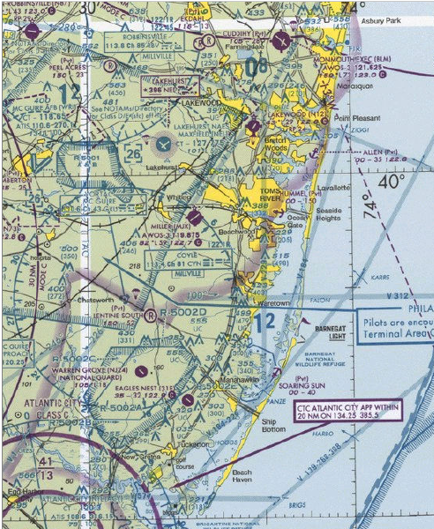
Latitude _______ᵒ_______’ Longitude _______ᵒ_______’

